

X



CEWPMOD 2 – Introduction to Web Programming – Deliverable D2

Finalization of DiamondRims™

Kevin D. YAKER // Arnak TOVMASSIAN // Arnaud SAULOU1*

Instructor: Mr. KAMTHAN, Pankaj  
*1Department of Computer Science and Engineering, EFREI Paris, Villejuif - France  
*(*Authors for correspondence : Kevin.yaker@efrei.net & Arnak.tovmassian@efrei.net & Arnaud.saulou@efrei.net )*(Received and approved in its final form the 5th March 2020)

**Groupe A – Team “Dubai Cartel”**

Contents

A. Introduction 3

I. Project presentation 3

B. Project Development 4

II. Front end 4

i. Description and functionality of each page: 4

ii. Home page: 5

iii. Products page: 6

iv. Product detail page: 7

v. About us page: 10

vi. Login page : 11

vii. Manage page: 12

III. Back End 13

i. MCC/tables: 13

ii. Axis of developments: 14

iii. Validators & Conclusion 14

C. References 14

# Introduction

This part of the report will act as a refresher but also a quick reminder of what happened in the D1 of this project, where a more developer-like approach was tackled. For this D2, a more enterprise approach will be taken, to explain the final stages of the project and all the steps of the process.

## Project presentation

Diamond Rims is an online luxury car dealer that puts buyers in relation to vendors. Firstly, there will be only one vendor. Customers that are looking for a luxury car came on the website where they will be able to search for their dream car. The project is a basic CRUD web application with two type of access:

- A “client type” user that can just visualize the cars, switch from page to page, search for a specific car and see the details. Some filters to precise their research will be available, examples would be sorting by brands, model or even mileage.

- An “administrator type” user that can do everything a “client type” user can do , except that , the “admin type” will also have access to a connection page that will allow him to add, delete and modify information about the cars available on the website. Those features will arrive with the second release.

The application will have to be linked to a database to store different information about all the cars like their model name, brand, color, motor, description, images and price.

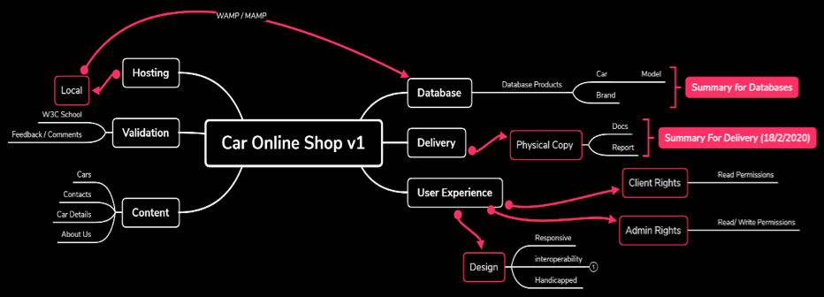

Figure 1. Mindmap V1 of DiamondRims

The above mind map gives us an overall idea of what happened through that “filtering brainstorm session”. This one will be extremely efficient for the “end-game” of the project, to have a clear idea of what needs to be prioritized and tackled as fast as possible. And this for numerous reasons, both time efficient and work efficient.

Now that the introductory page and also refresher page is done, the website development and finalization stage can begin, numerous screenshots will be added through the writing and completion of this report, some additional text / resources will also be included in the sources and appendix section of this report.

Some limitations did occur through that project, these will be partially tackled, but also ways of completing them and optimizing the overall website will be detailed.

# Project Development

This part will tackle the front and back end development of the project, while showing specific aspects of the websites (using screenshots and other features such as W3C validators).

## II. Front end

Our website is composed of 6 principal pages that are completed and fully responsive:  
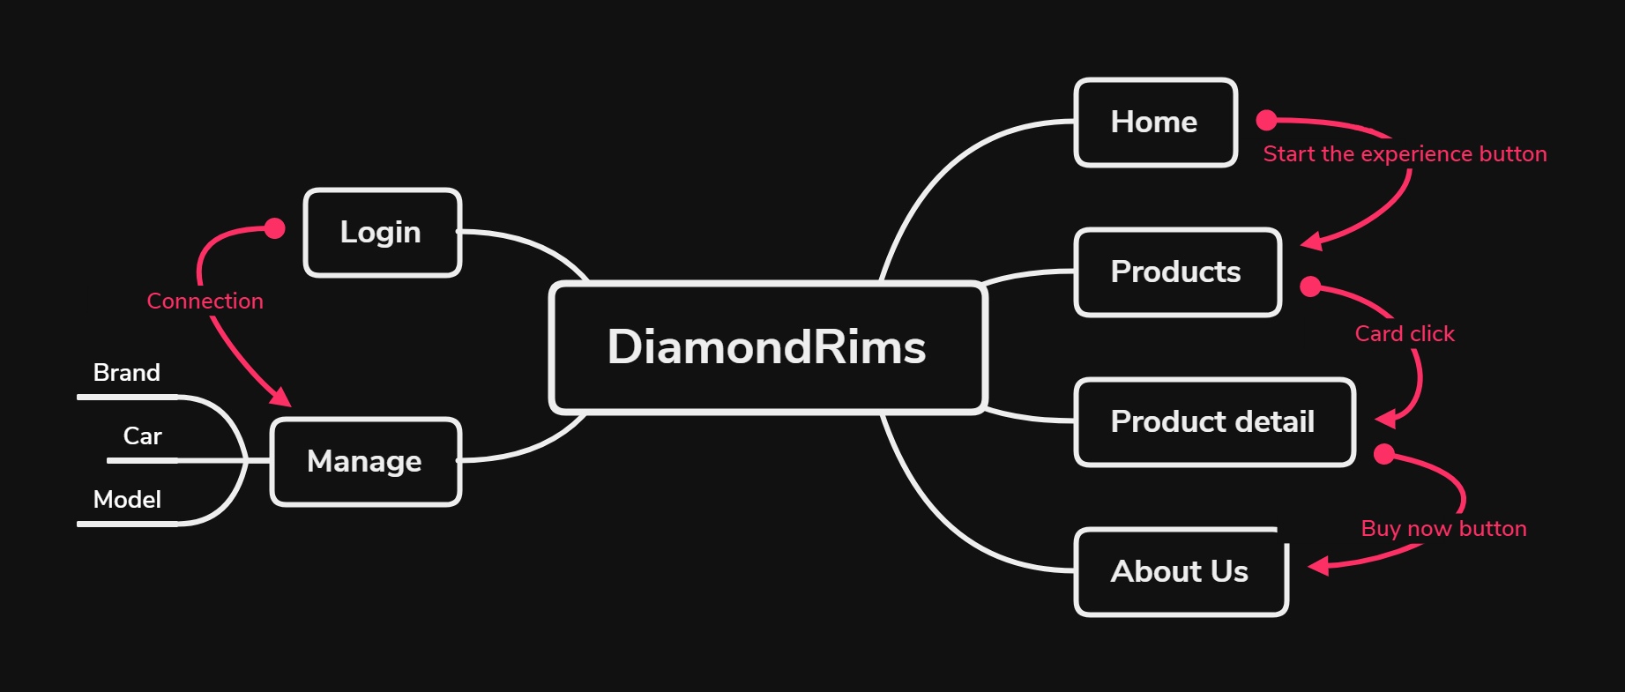

Figure 2. SiteMap of DiamondRims

This SiteMap is an extremely powerful tool in the world of SEOs to have an quick and thorough analysis of what the website is supposed to be made of, and what each page should be linked to.

### i. Description and functionality of each page:

You can access every page of our website through our navigation bar. For design reasons, a same hex color of “matte black” was used for all the navigation features (#454545); the navigation bar possesses by default 2 mode, a guest mode, and an admin/user mode, as it is visible in figure 3. With a logout feature (this feature will be explained in further detail into the report).



Figure 3. Demonstration of the navbar (Desktop Mode)

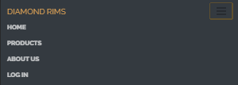

Figure 4. Demonstration of the navbar (Mobile mode)

### ii. Home page:

Our home page presents our company and has all the recent information and articles about us. You can access our products page by clicking on the “Start the experience” button. This page required to be the most “appealing to the eye” and user friendly. As it can be seen on the following screenshots. The home page by default will use some Bootstrap 4 framework and some PHP AJAX for a dynamic modification between the user and admin mods.

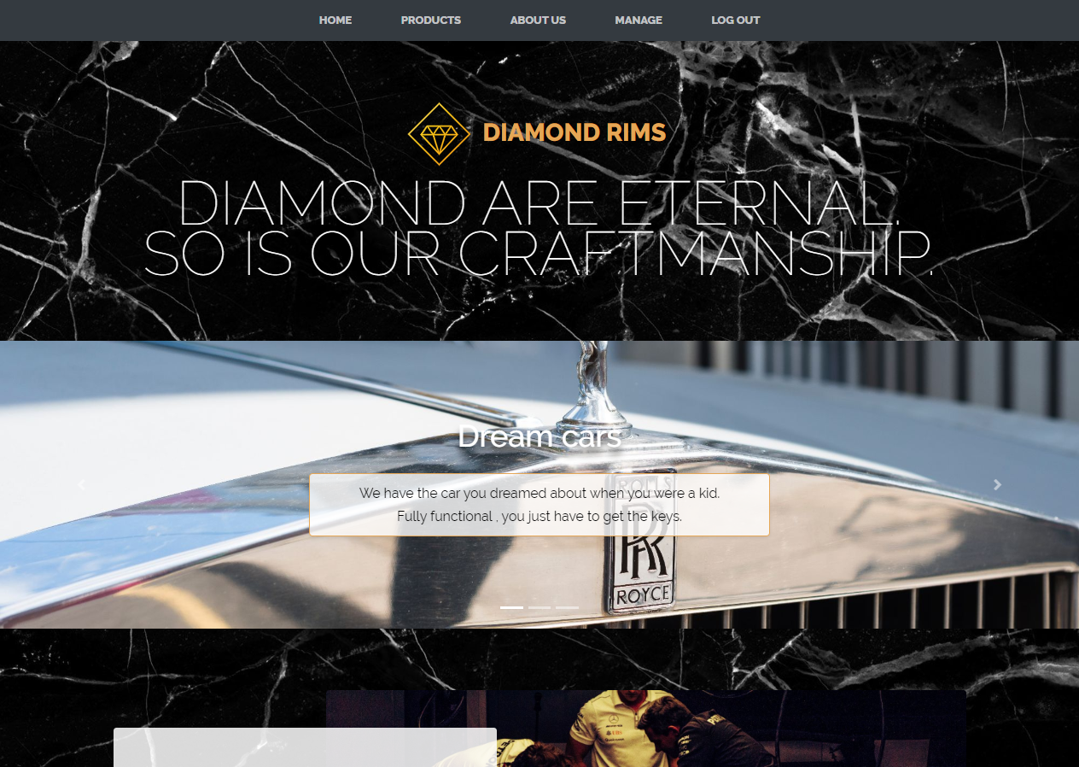

Figure 5. Homepage (Desktop mode)

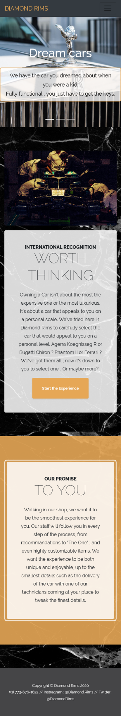  
Figure 6. Homepage (Mobile mode)

### iii. Products page:

The product page has all the products our company possesses and sells. The different information of every product is taken from our database and is shown on our page. The user can click on a car card and access the Product detail page. This page was done using MariaDB for the SQL gestion, WAMPServer as local APACHE server (the entire project will stay as local project due to licensing issue on the images), most medias were acquired from the official press kits of the concerned brands.

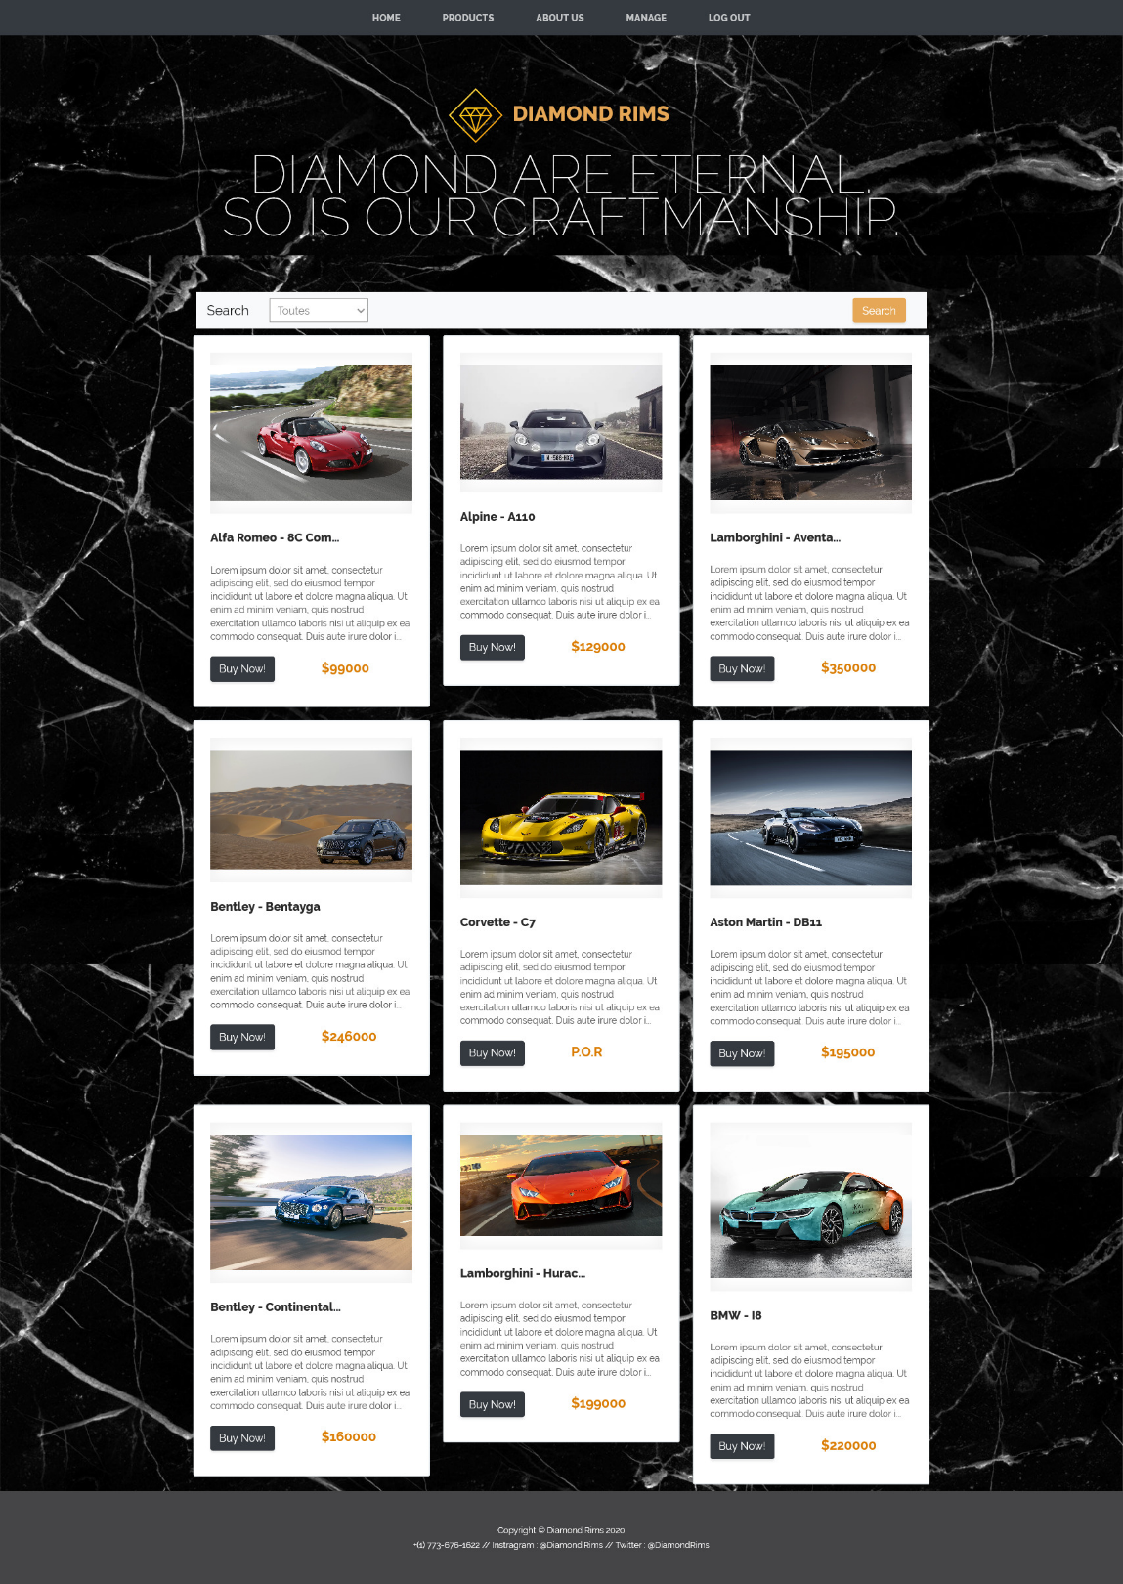

Figure7. Product page (Desktop mode)

### 

### *Figure 8. Product page (Mobile Mode)*

### iv. Product detail page:

The product detail page shows more information and details about the selected car. The user can see other pictures about the product on this page, and he can also click on the “Buy now” button that will redirect the user on the About us page. The reason for that, is mostly to keep an exclusive experience, some of the cars being so luxurious a P.O.R policy (Price on Request) is applied. Also, such colossal payments would require multiple verification through banks.

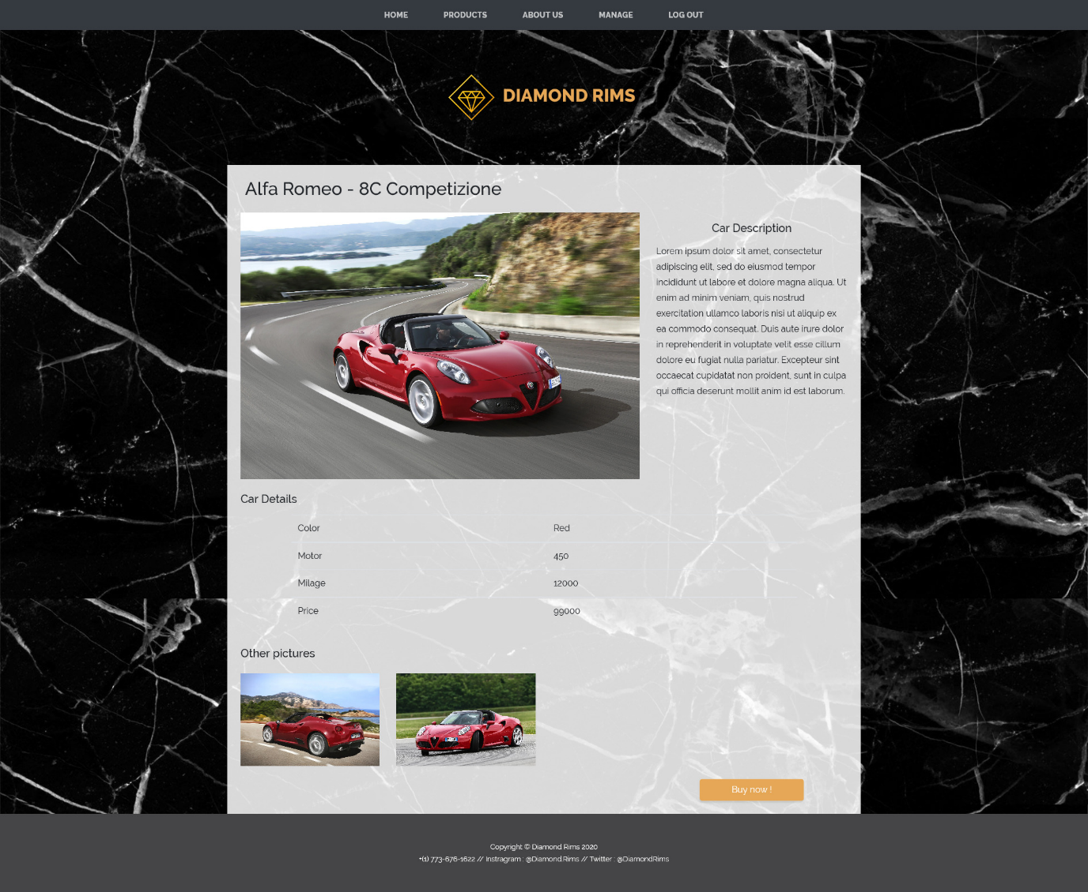

Figure 9. Details product page (Desktop Mode)

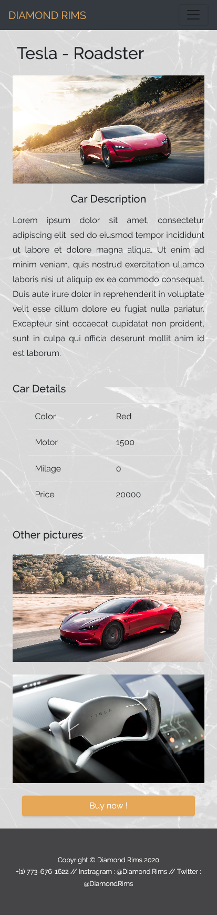

Figure 9. Details product page (Mobile Mode)

### v. About us page:

The about us page is a simple page containing information about the company and how to contact us. This one is a standard HTML page with plaintext information, and also contact information.

### 

Figure 10. About us page (Desktop Mode)

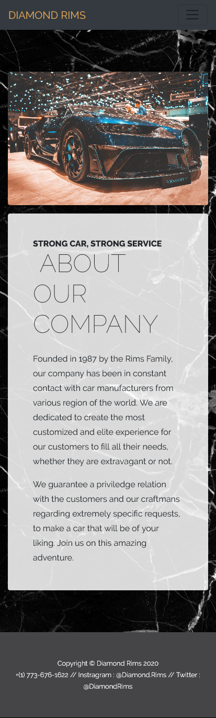

Figure 11. About us page (Mobile Mode)

### vi. Login page :

The login page is a classic page for the user to connect and access to the “manage” page in order to add and modify content in the website. This one will be handled through 2 software, MariaDB and PHPMyAdmin; for security measures, each account will run an encrypted password followed by a hash in base64, with an unique SALT identifier.

The login page will also possess a success or denied login, that will redirect you either to the admin panel, or the login page again, some internal cooldown got also put in place.

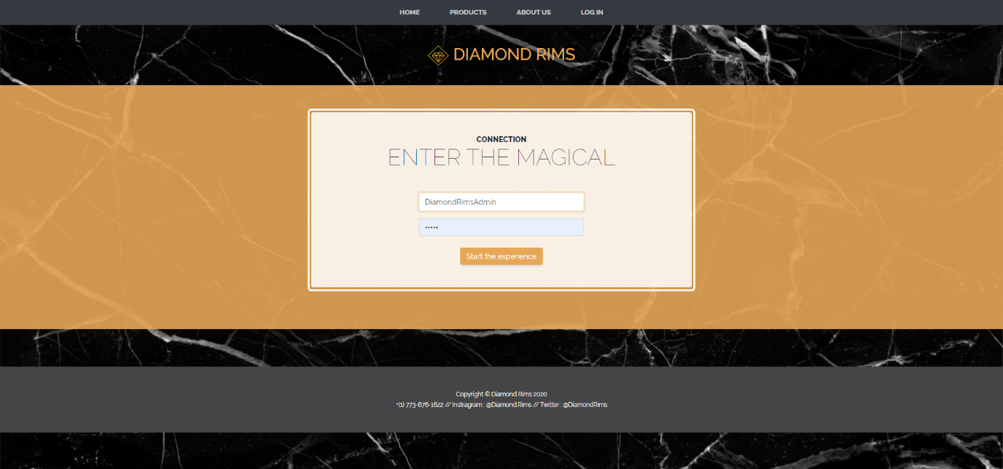

Figure 12. Login page

### vii. Manage page:

The manage page here acts as our admin dashboard, allowing with a clearer UI to add or delete entries in the database, this would allow a friendlier interface for future clients that don’t have in depth knowledge in PHP / SQL. Each category can be modified through the model / car / brand, etc. Note that all manage pages aren’t responsive because the website is not supposed to be manage on a smartphone.

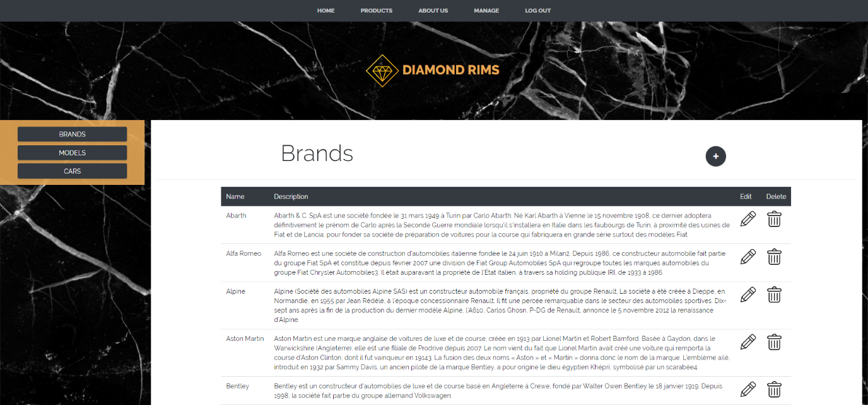

Figure 13. Admin dashboard

## III. Back End

### i. MCC/tables:

To create the database, we have used the MERISE techniques to be able to collect data, save them, treat them and broadcast them. We first identified the CDM (Conceptual Data Model) by:

- Implementing the management rules.

- Developing the data dictionary.

- Searching for functional dependencies between these data.

- Creating entities and associations, then calculation of cardinalities.

From the CDM (Conceptual Data Model) … :

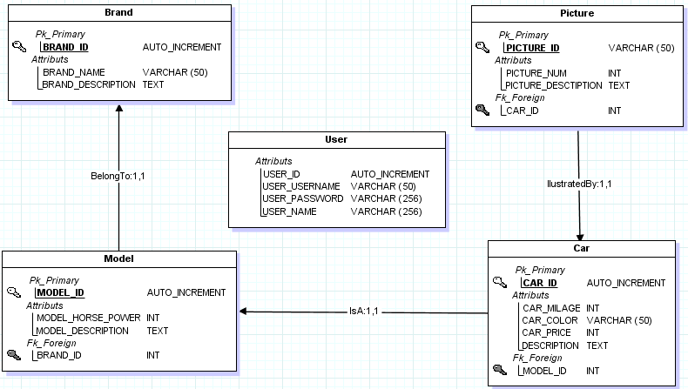

… to the LDM (Logical Data Model) :

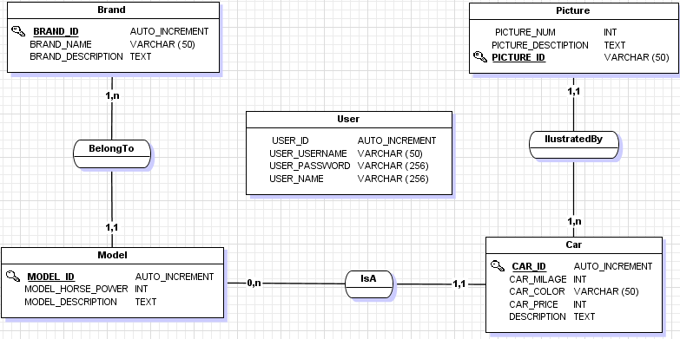

Figure 14. Merise method from MCD to MLD

### ii. Axis of developments:

For our project we thought about 3 main improvements axes :  
- Add a basket function for the clients , that will stock all the products the clients want to buy.  
- Add a register page for the clients , in order for each client to have an account on our website and get mail on our latest products.  
- Improve the content of our database by adding more cars and details.  
- Internationalization of our website in order for foreign clients to understand and use our website.

### iii. Validators & Conclusion

The uses of numerous validators were used to verify the overall integrity of our work, the most reliable and famous one is the W3C Validator, this one was used through the acquirement of a Mozilla Firefox plugin call “W3C Validator” ; which was able to read on the go and say which areas were faulty in our code. Beside we have test our web application with the Google Lighthouse Standard, we tried to reach the perfection (100% in each domain) but since it’s a small project, build on local resources, some tests are irrelevant.

To conclude, this project was most of the time smooth sailing, through the use of corporate-like approach and methodology, the deadlines were respected, and everyone had to use their unique skillset to make the work go smoothly.

# C. References

- Bootstrap Framework 4

- PHPMyAdmin

- AJAX

- MariaDB for SQL Handling

- JQuery